FC6P01 – Project WIRELESS cOMPUTER

Simon Renault - 13027755



FC6P01 Project

Final Report

Wireless Computer

|  |  |
| --- | --- |
| Module:  Deadline:  Module Leader: | FC6P01  Wednesday 11th May 2016  Dr Richard Walters |
| Name:  ID Number: | Simon Renault  Student 13027755 |
| First Supervisor:  Second Supervisor: | Dr Saeed Taghizadeh  Dr Hassan Nabijou |

# Declaration

## Plagiarism

You are reminded that there exist regulations concerning plagiarism. Extracts from these regulations are printed below. Please sign below to say that you have read and understand these extracts:

(signature:)_____Simon_Renault___ Date: 12/05/16

This header sheet should be attached to the work you submit. No work will be accepted without it.

Extracts from University *Regulations* onCheating, Plagiarism and Collusion

Section 2.3: "The following broad types of offence can be identified and are provided as indicative examples…

1. Cheating: including taking unauthorised material into an examination; consulting unauthorised material outside the examination hall during the examination; obtaining an unseen examination paper in advance of the examination; copying from another examinee; using an unauthorised calculator during the examination or storing unauthorised material in the memory of a programmable calculator which is taken into the examination; copying coursework.
2. Falsifying data in experimental results.
3. Personation, where a substitute takes an examination or test on behalf of the candidate. Both candidate and substitute may be guilty of an offence under these Regulations.
4. Bribery or attempted bribery of a person thought to have some influence on the candidate's assessment.
5. Collusion to present joint work as the work solely of one individual.
6. Plagiarism, where the work or ideas of another are presented as the candidate's own.
7. Other conduct calculated to secure an advantage on assessment.

(viii) Assisting in any of the above.

Some notes on what this means for students:

1. Copying another student's work is an offence, whether from a copy on paper or from a computer file, and in whatever form the intellectual property being copied takes, including text, mathematical notation and computer programs.

2. Taking extracts from published sources *without attribution* is an offence. To quote ideas, sometimes using extracts, is generally to be encouraged. Quoting ideas is achieved by stating an author's argument and attributing it, perhaps by quoting, immediately in the text, his or her name and year of publication, e.g. "e = mc2 (Einstein 1905)". A *references* section at the end of your work should then list all such references in alphabetical order of authors' surnames. (There are variations on this referencing system which your tutors may prefer you to use.) If you wish to quote a paragraph or so from published work then indent the quotation on both left and right margins, using an italic font where practicable, and introduce the quotation with an attribution.

# Summary

This report presents the path to completion, the knowledge used and acquired and the results of the final year project: Wireless Computer, which aims to produce a prototype of a measurement station (Temperature, Humidity, Light, Pressure) communicating with a Host PC wirelessly (over ~1km) allowing manipulation and storage of the data transmitted in a graphical user interface (GUI) fitting the system.

It would allow measurements in areas difficult to access, or with climate conditions making long stay for human complex.

Therefore, this system needed to be power efficient, show high rate transfers, provide accurate samples, have reliable remote capabilities in order to meet the given requirements. These have been addressed through the choice of the components, such as a power-friendly microcontroller, the integration of a battery and a solar panel, powerful RF modules and an array of strong sensors, able to work in adapted range of weather conditions. Sensors, microcontrollers and other necessary components able to answer these requirements have been selected and tested.

The first timeline established was not fully respected, but wise organisation and division of tasks helped to produce a prototype with its working system within the dedicated time. The main requirements and most of the secondary goals have been met, and through testing the prototype can be described as successful in answer to these requirements.

This report can also be used as a foundation to guide building this system another time, and could be of use in case of mass production. A technical and academic explanation will at first be presented, showing the challenges met and their responses, followed by a time and pricing approach to help establishing a cost and effort guide to the product.

The technical and academic aspect of the project will be divided in such that the wireless unit will be present in first place, followed by the means used to transmit the data to the host computer, and will be concluding on the graphical user interface (GUI) and how to access the data. The report will end on bringing a short explanation on economy, knowledge and time related matters and how they were addressed.

# Contents

Declaration 2

Plagiarism 2

Summary 3

Contents 4

Introduction 6

Initial project description and functions 6

Final project description and functions 6

Wireless Data Transceiver (WDT) 8

Processor - Introduction 8

Sensors - Introduction 8

Arduino – Testing the System 9

Sensors Configuration and Testing 9

A - Temperature and Humidity 9

B - Light Intensity 10

C - Pressure Sensor 12

On-Board Display and Memory 12

Battery and Solar Powered Unit 13

On-Board Controls 13

Working system 13

Raspberry Pi – Final Version of the System 14

Differences with previous systems 14

Installation – Operating System 15

Installation – Libraries 16

Sensors Configuration and Settings 17

A - Humidity 17

B – Altitude, and Temperature, Pressure and Sea Level Pressure 18

C – Luminosity 18

D – Time and Position 19

On-Board Memory 20

Camera 20

Wheel System 20

Powering, Battery and Solar panel 22

WDT Prototype/Circuit 22

Aesthetics 23

Data Transmission 24

Data Transmission from Wireless Unit to Reception Unit 24

Wireless Transmitting Device (RF) 24

Xbee on Raspberry Pi 25

Data to be transmitted 26

Host PC 27

Data Upload 27

Database server 28

Proof of concept – Access the database server 29

Data Access and Manipulation 30

Website 30

Amazon Web Services 30

Webserver side 34

Dashboard 34

Other types of Data 36

Working example 37

Conclusion 38

Time management 38

Economic and Ethical aspects 38

Progress Review 38

References 39

# Introduction

This report aims to present the steps followed to achieve a prototype and its state at the time of the writing, to answer and meet the requirements of the final year project: “Wireless Computer”. The project has known several and heavy modifications to its structure. As of the choice of processor and components, or the way to access the data at the reception end. This introduction will first describe its initial condition, and then its final state.

# Initial project description and functions

The initial goal of this project was to produce a prototype of a Wireless Unit, which would take measurements of Temperature, Humidity, Pressure and Light Intensity. It would then report these measurements to a computer that will be able to run calculations and store them. Here is a diagram representing the project:

**Wireless Data Transceiver**

**(**

**WDT**

**)**

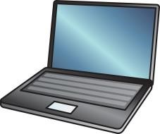

(

a) Wireless Data Transceiver

(

b) PC Host

Figure : Diagram Representation of the project

*“This report will first show the Background research conducted, followed by the completed work and tasks. Then the work needed towards completion will be approached, as well as the Progress Review, in which will be assessed the feasibility of the project, by comparing the work done with the project plan.*

*For each step of this report, the structure is identical to the one of the Project. It is divided in two main parts: A Wireless Data Transceiver (Its Processor, Sensors, on-board Display and Memory, Wireless transmitting system, Battery and Solar Charging system) and a Computer unit (Its Wireless transmitting device, Connection and Graphical User Interface). “*

# Final project description and functions

The function of the project follows the same functions and features, but at an extended range.

The main change, is the cloud database presence in the system. It allows access to the data from anywhere in the world, for as long as there is an internet connection. It was developed with the aim of being accessed easily, having the transfer/upload of data possible at high rate from a serial port device. It also needed an easy to manipulate graphical interface, so the user could access data and related information with the less effort possible. The answer to these new requirements appeared in the form of a website, and are accessible at all time at the following address: <http://remotebot.tech>.

Smaller changes, as increasing the number and quality of sensors was added as well.

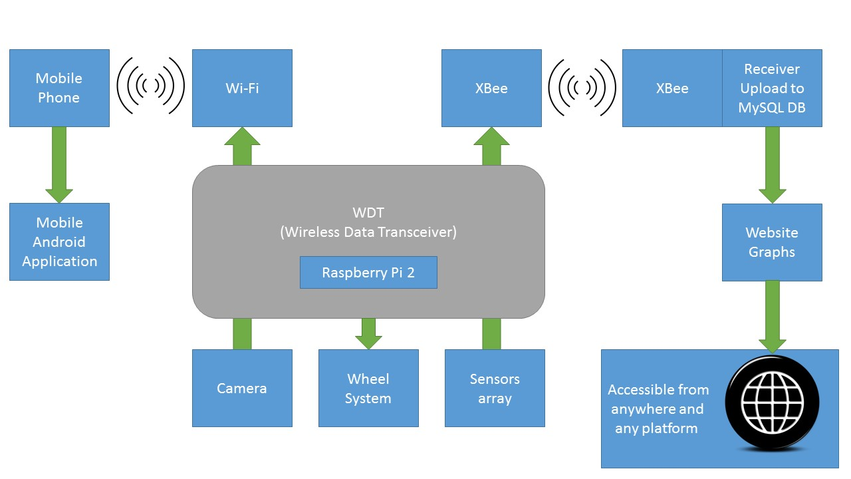The following diagram represents the project functions, by dividing its features into blocks, and connecting them with the actual media in use:

Figure : Block Diagram of the project “Wireless Computer”

On the core modules, of the project, can be seen that the modifications were as stated on the database side, as the transmission means and sensors functions are mainly the same.

It can be brought to attention that other blocks were incorporated in the system, as the wheel system or the Camera, providing extra sections, and room for even further development.

The above diagram is to be understood as following:

* The sensor array, takes measurements, that will be transmitted to a host computer via Xbee, and then upload to a MySQL database from which a PHP and HTML/CSS website will take the data to offer a fitting GUI.
* On the other side, an Android mobile app will offer to have access to the camera, see in real-time what the robot sees, and also to control its wheel system, to allow movement. Transmission will be done via Wi-Fi.

Not all these sections are fully developed, and there is room for expansion left. By the time of the viva, a fully working prototype might be presentable.

First will be presented how was designed the WDT (Wireless data Transceiver), then the data transmission and finally the host computer. The time line respect and the tasks management will be commented before the conclusion, which will end this report.

# Wireless Data Transceiver (WDT)

The Wireless Data Transceiver has been the point of focus, as depending on its “output” the configuration of the reception end would change. Starting by its sensors, and then the processor and type of communication, the selection process was done through testing multiple combination. The criterions of selection will be explained in their respective sections [2]. The work carried on the WDT will be structured by the processor on which the testing was done, then explanations of every sensor and system that was implemented.

## Processor - Introduction

Among the microcontrollers and processors tried, can be found different types of Arduino boards (Mega, Uno, Micro, Nano), EFM32 Gecko andSTM32 discovery which are microcontrollers using C programming, BASYS2 and CPLD which are VHDL boards, and finally, the Raspberry pi (ver. 2B+).

The processor was first chosen over these parameters: power-efficiency, number of external ports, special features, cost (if needs to duplicate the device), ease of use, and reliability. With these expectations, was chosen the EFM32 Gecko as it had the best power efficiency, enough ports for all sensors and the communication device and extras if needed in the future. An easy-of-use interface and program debugger, called Simplicity Studio. The form factor was also interesting as even with an impressing number of ports it stays very thin. It had a built-in display and set of buttons, and a “watch battery” adapter, so a backup battery could be set directly on our microcontroller (Datasheet: [1]).

But as the features were tested one after the other, the choice moved to Arduino, as the strong community and support allowed to have pieces of hardware and sensors working while it wasn’t possible with the EFM32 Gecko. Will be shown in the dedicated section all the work done with Arduino boards.

Once again, as the features started to accumulate on such a tiny processor, was seen the lack of speed and performances in the execution of the scripts, even before the camera system could be tested. And so was decided to move on the strongest processor of all available on such small form factor: The Raspberry Pi. It is known that the Raspberry Pi is far from offering the same low-power consumption or small size factor, or even weight, but its processing power is strong enough to have it running as an every-day computer, and on all other aspects, it offers better performances.

## Sensors - Introduction

Most the following sensors have been provided by the University supervisor. A reference to their way of function is listed for each of them:

* Temperature and Humidity sensor – DHT11, DHT22 and AM2302 [3]
* Light Sensor – VEX [4], then simple LDR
* Pressure sensor – BMP180 [5]
* Real Time Clock – DS1307RTC
* Position – GPS - Ublox NEO-6m
* Rain Drop Sensor –
* Camera - PiCamera

## Arduino – Testing the System

This section is present in the report, because the testing of the sensors on Arduino hasn’t been wasted time. It allowed to quickly reconfigure them with the Raspberry Pi, and also to ensure the quality and compatibility with the suggested processors.

Arduino was seen at first as a backup plan if the EFM32 Gecko wouldn’t work, and afterwards if the Raspberry Pi wouldn’t be setup in time. The easy to use and straight-forward interface with the strong community support it offers are the reasons for which the platform has been chosen to run the tests.

This section will at first present the work done to have the sensors working with Arduino, followed by the screen and memory support, to conclude on the battery and solar-powered aspect of the device. It is to be understood that this preliminary work was very helpful when connecting the Raspberry Pi, as the sensors understanding was strongly enhanced after having used them with Arduino.

### Sensors Configuration and Testing

Here will be presented the work completed on the sensors of the Wireless Data Transceiver (WDT) which have been tested with an Arduino UNO Rev3 microcontroller.

With the use of simple codes to determine output type, rate and quality, and following the project requirements, four parameters measures were set on the WDT. Pressure is missing in this section as the corresponding sensor hadn’t arrived at the time at which the decision was taken to switch to Raspberry Pi.

#### A - Temperature and Humidity

These two parameters are set together, as the DHT11 sensor measures both. In the figure below is shown the circuit to connect the DHT22sensor to an Arduino Uno:

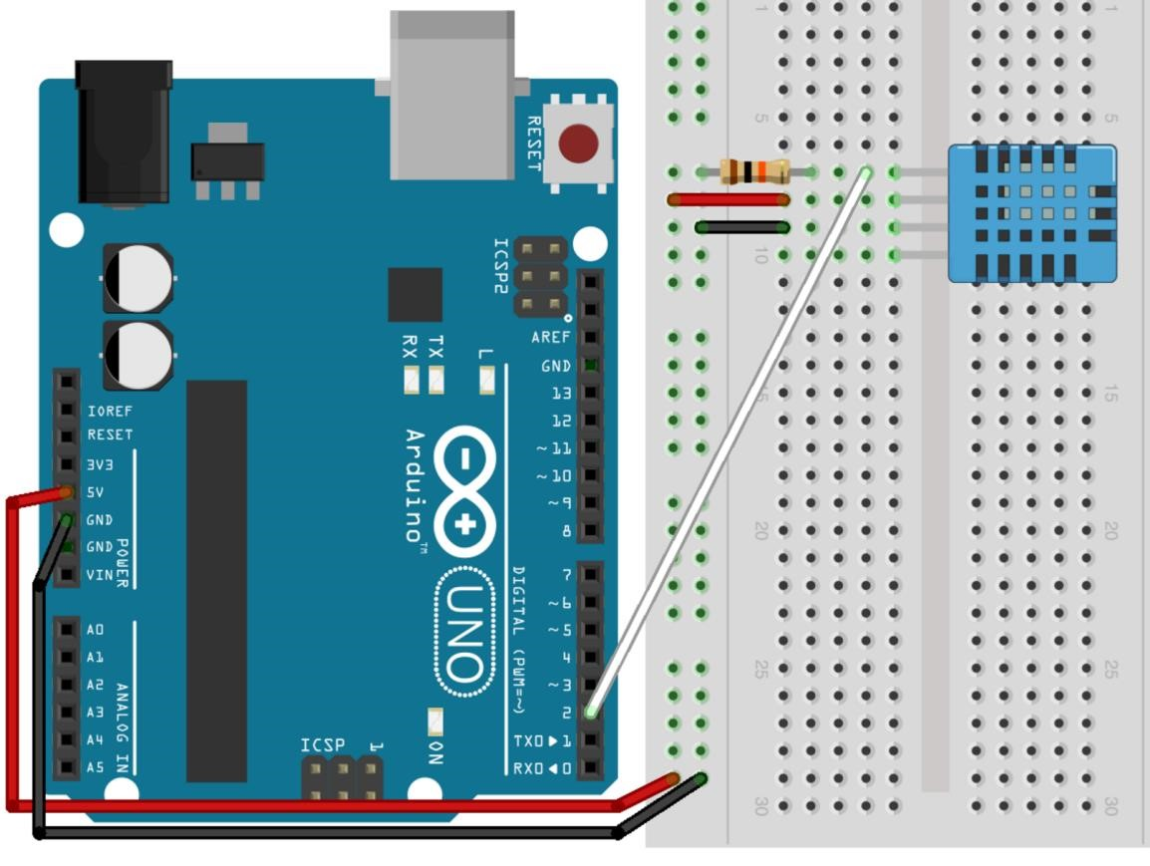

Figure 3: Arduino Code and Serial Monitor for DHT22sensor

The circuit shows connections for a DHT22 sensor, which has the same pins connections as the DHT11does. There is a pull-up resistor connected to the output.

Here is the Arduino code used to test it with the results it provided:

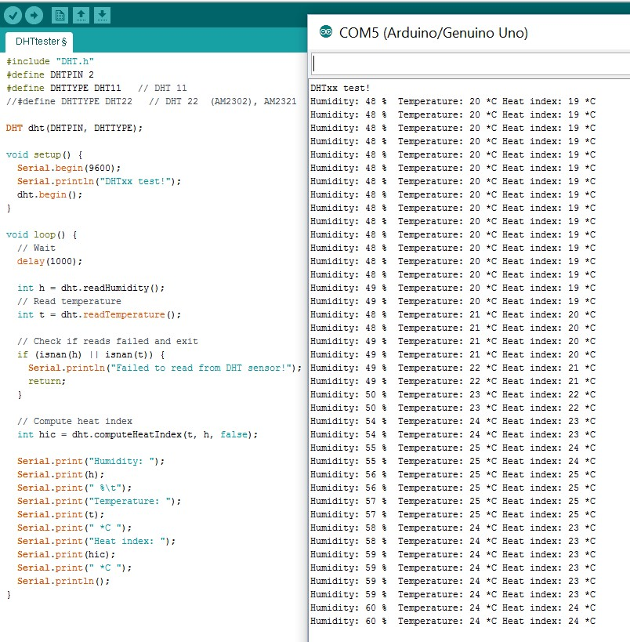

Figure : Arduino Code and Serial Monitor for DHT11sensor

This sensor has been tested with the default Arduino libraries (“**DHT.h**”), due to the complexity of the output it provides. The provided Arduino libraries allows to simply use “readTemperature” or “readHumidity” to make the measurements, and calculate the Heat index as well by calling the “computeHeatIndex” function.

The provided DHT11 sensor had a weak sampling rate and a strong delay in the measures. For better results, it was then decided to replace it with a sensor from an upper range of the same brand, the DHT22. It provides both Temperature and Humidity measures as well.

#### B - Light Intensity

The Light Intensity will be measured by the VEXLightSensor. There is no circuit to present the connections of this sensor, as it is very straightforward. It has three pins: positive (+3.3 to +5V), Ground, and output. It is an easy-of-use analogue Light sensor.

Here is the simple piece of Arduino code used to test the sensor:

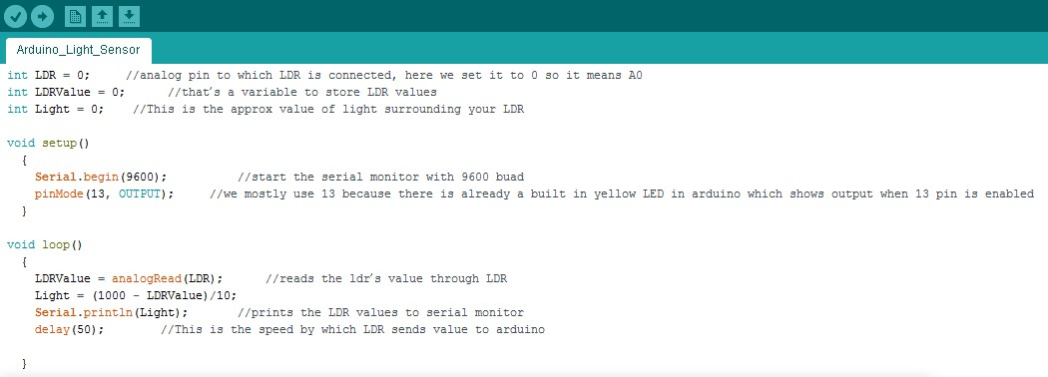

Figure : Arduino Code for VEXLightSensor

This code uses the serial monitor of the Arduino software to display the output, and take a measurement every 50ms. The raw signal received by the filter was such that the strongest luminosity appeared as a value close to 0, and close to total darkness, was a value close to 1000. To bring it to a percentage, the following equation is inserted in the loop of our program:

Percentage of Luminosity = (1000 – Value of the sensor output) / 10 It allows to display the “Luminosity” calculated from the output of the light sensor, as shown in the figure below:

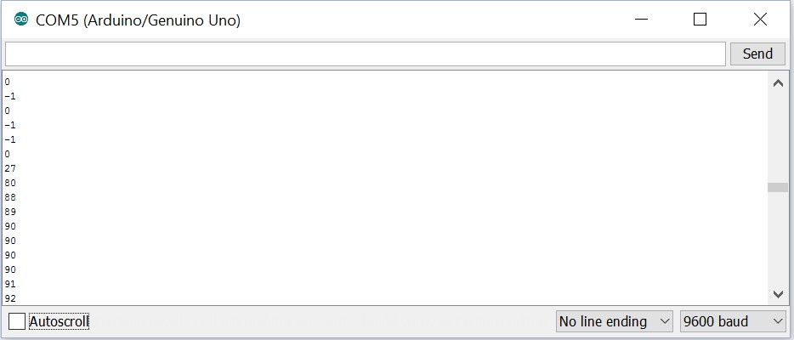

Figure : Arduino Serial Monitor for VEXLightSensor

As provided by the figure above, the value is always contained between 0 and 100, and represents the percentage of Luminosity received by the sensor.

Small errors such as -1% and 101% can appear as shown above, but this sensor has been proved to be of easy use, and brought accurate results with a respectable speed. The VEXLightSensor had met the requirements, but speed, accuracy and long-term use tests were to be done.

#### C - Pressure Sensor

The first Pressure sensor ([BMP180)](http://www.ebay.co.uk/itm/401004477814?_trksid=p2057872.m2749.l2649&ssPageName=STRK%3AMEBIDX%3AIT) arrived faulty, and its replacement is due to arrive on the second of January. Tests to be done from this date.

### On-Board Display and Memory

The device chosen to display information on the WDT, was a 1.7” TFT LCD Screen (A000096), provided by Arduino studios, and has a SD Card reader underneath. The Figure below shows its real appearance and the ports it offers:

Figure : On-Board Display and Memory module

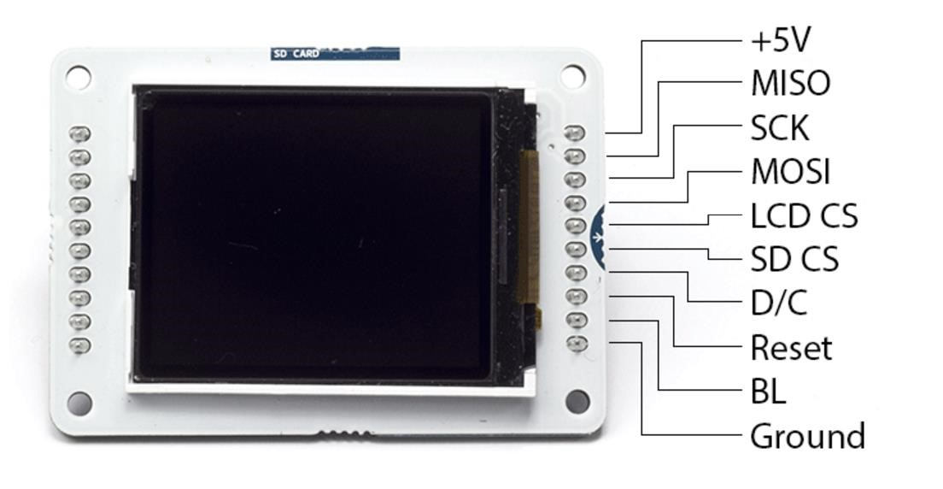

This product will allow both to display information and to store data. It will in the same time allow to save the space of having a device for each function. (Datasheet: [9])

The microcontroller has power pins on its left end, allowing connections to any sort of mobile power supplies. As shown on this forum [7], it has been one of the favourite way of alimenting this microcontroller.

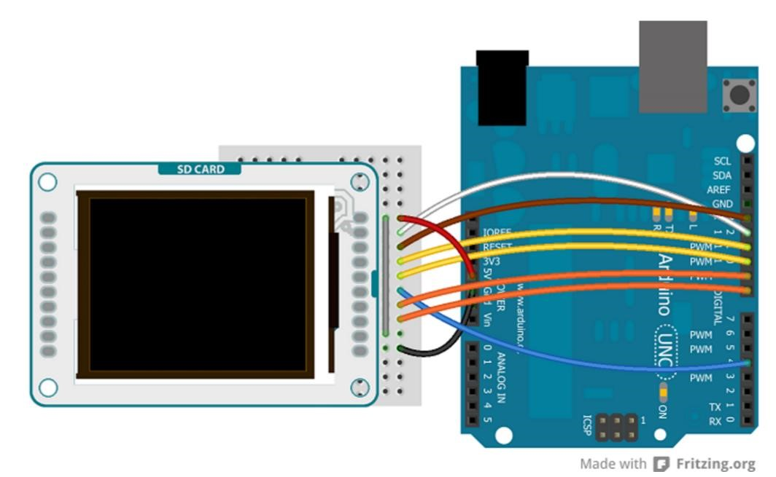The 1.7” TFT LCD screen will be positioned on the WDT. It will also contain a SD card slot to provide memory to the device. For now, it uses the Arduino TFT libraries to run. Here is the circuit to connect the device to an Arduino UNO:

Figure : 1.7” TFT Module with Arduino, Circuit Diagram

Here is a picture of the working screen:

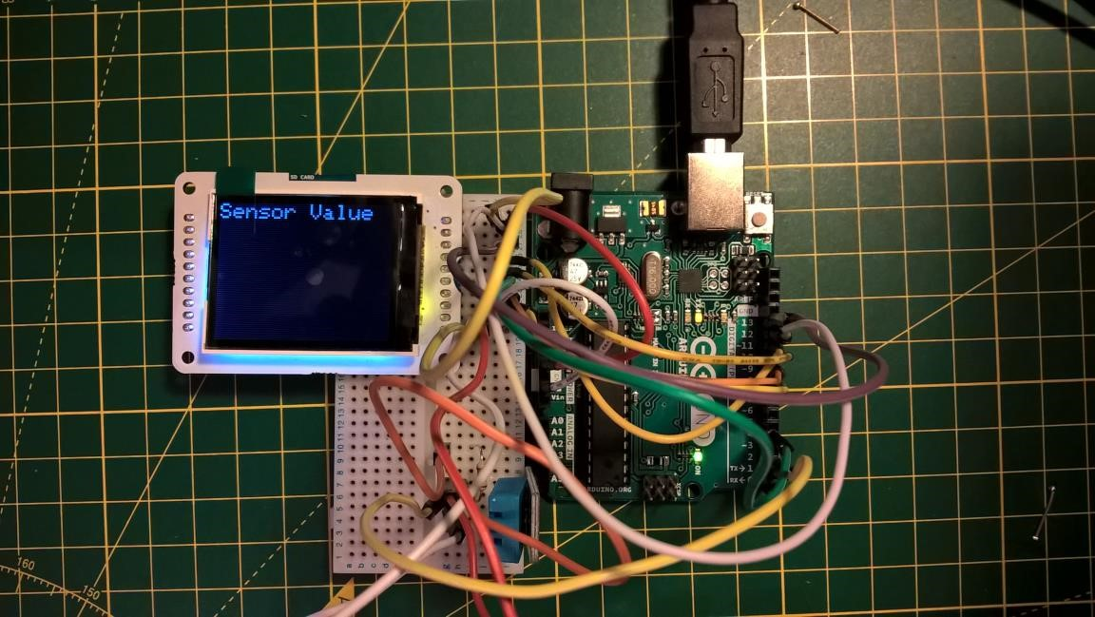The SD Card hasn’t been tested or use, as its configuration alone was slowing the transfer speed of the data.

Figure : 1.7” TFT Module with Arduino, Circuit Picture

### Battery and Solar Powered Unit

The components and circuit are gathered and known. It needs to be assembled and tested, with the final configuration of the WDT. These tests are run at the end to ensure the ability of the power system to supply the final WDT prototype.

It is a 5V Solar panel with a 10.8V/ 2250mAh Battery.

Figure : Power components (Battery and Solar Panel)

### On-Board Controls

A set of controls was set on the device allowing simple operations to be done when in contact with the WDT. It used buttons to operate, and LEDs to show status of the sensors and components. The final status of the control system resulted being a single button to navigate through graph, and to show or hide screen to lower the power consumption of the screen.

### Working system

A video of the working system with Arduino, can be found on the following link:

## Raspberry Pi – Final Version of the System

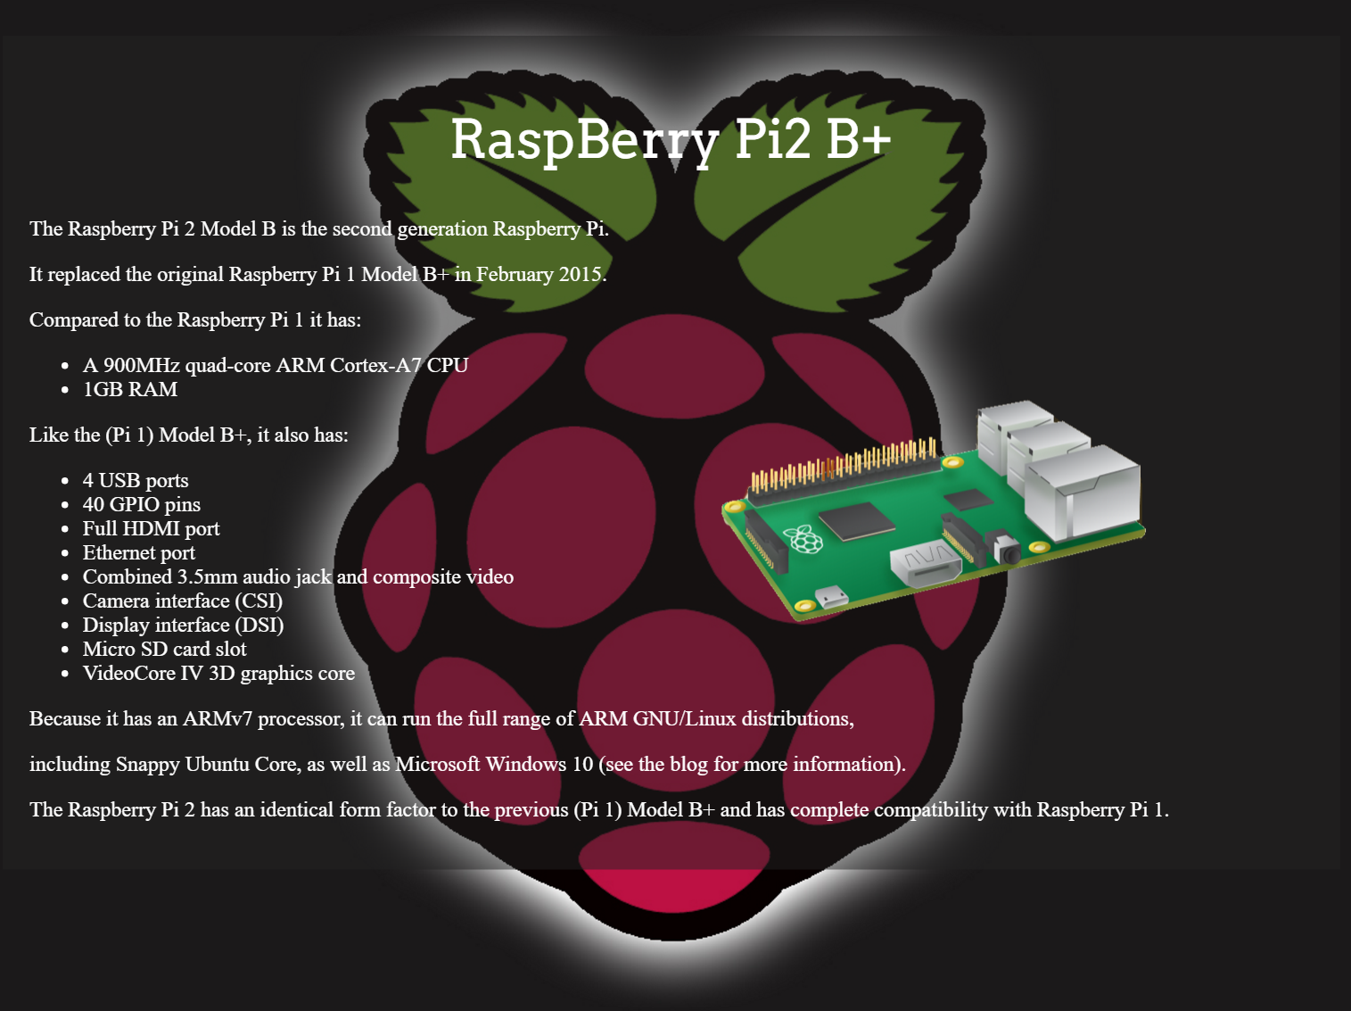The Raspberry Pi offers the following specifications (see [www.remotebot.tech](http://www.remotebot.tech)):

Figure : Raspberry Pi specifications

### Differences with previous systems

It is a very powerful system as stated above. It has a processing power even not comparable to the one of an Arduino, but only offers digital input and outputs while Arduino offers Analogue inputs. The point of this remark, is that having multiple analogue sensors, there is a need to find a solution on how to access the data they would transmit.

A solution is to use an RC circuit, and based on the resistance of the sensor (photo resistor for example on an LDR) the time for which the capacitor would charge will differ. It is very well explained on this page, and was used as a base to try having sensors to work (<http://www.raspberrypi-spy.co.uk/2012/08/reading-analogue-sensors-with-one-gpio-pin>). Another solution was to use a [MCP3008](https://learn.adafruit.com/downloads/pdf/reading-a-analog-in-and-controlling-audio-volume-with-the-raspberry-pi.pdf), but then it was decided to slave an Arduino Nano to the Raspberry Pi was easier of use, would use about the same processing power and even allow to work on data acquisition at an earlier state.

### Installation – Operating System

At the time of installation, and unlike Arduino that works out of the box, the Raspberry Pi needs to have an operating system installed. The two best OS for sensors and electronics managing/ monitoring are Raspbian and NOOBS. It was chosen to install Raspbian and the steps below were followed to install it:

1. Download the image of the chosen OS (at <https://www.raspberrypi.org/downloads/raspbian>):

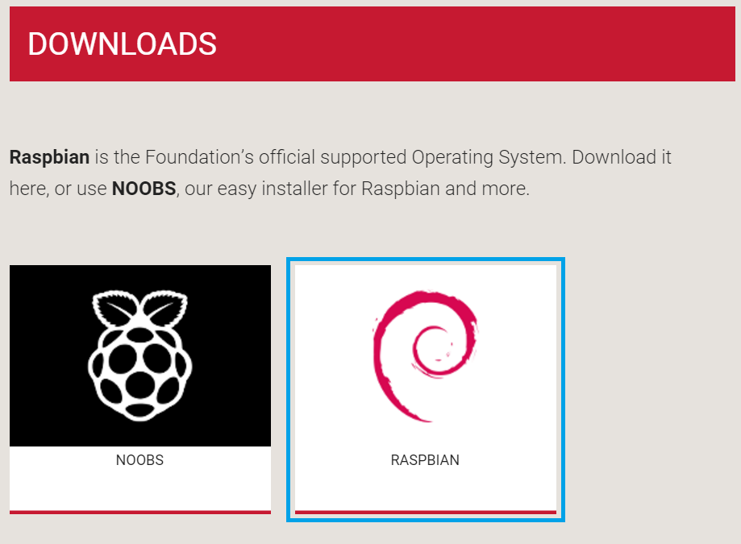

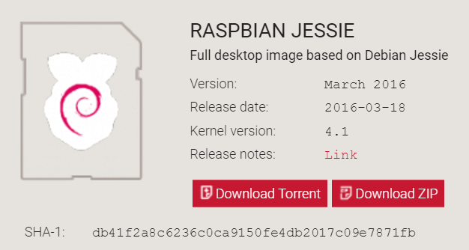

Figure : Raspbian Download

Raspbian is based on Debian, a very famous Linux distribution. It is tailor-made for Raspberry Pi.

1. Follow the following instruction, using Win32DiskImager utility:

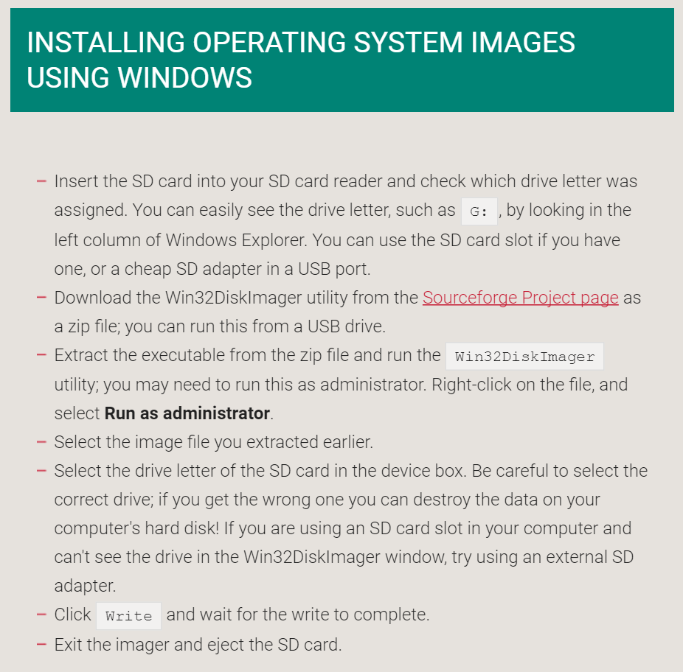

Figure 12: Raspbian Jessie Installation on SD card

After the previously explained steps, the Raspberry Pi is ready for use but comes with the need to have most of its libraries to be installed, which will be shown in the next section.

### Installation – Libraries

Libraries are a set of programs or drivers, specified for the operating system of the system that is going to be in control, and allowing to monitor and connect to the specified devices.

Each or most of the sensors use have their own libraries, and each of their installation will be explained in their assigned section.

There is the use to install other libraries, such as python and its different components, or its different versions depending on which sensor is used. Also, some other libraries such as C code reader had to be install, to allow drivers to be used for a few digital sensors.

### Sensors Configuration and Settings

All the sensor presented here, are the one listed in the sensor list at the beginning of this section.

This section is divided by sensor, and each part is named after the natural parameter it monitors.

#### A - Humidity

The DHT22 was used for the Humidity monitoring, as the temperature reading provided by the sensors were not accurate enough, and were taking too long to be provided.

Here is a diagram (Fritzing) on the right to show how it was connected to the Raspberry Pi. Can be seen that only three of the four pins are used, and also that a 10kΩ resistor is used as a pull-up resistor, to ensure a strong enough signal, at the right logic level.

Figure : DHT11 connected to the Raspberry Pi

The libraries provided by Adafruit are of easy use, and well integrate in Python. Can be seen below a short program to make the measurements:

|  |
| --- |
| import sys  import Adafruit_DHT  sensor_args = { '11': Adafruit_DHT.DHT11,  '22': Adafruit_DHT.DHT22,  '2302': Adafruit_DHT.AM2302 }  if len(sys.argv) == 3 and sys.argv[1] in sensor_args:  sensor = sensor_args[sys.argv[1]]  pin = sys.argv[2]  else:  print('usage: sudo ./Adafruit_DHT.py [11|22|2302] GPIOpin#')  print('example: sudo ./Adafruit_DHT.py 2302 4 - Read from an AM2302 connected to GPIO #4')  sys.exit(1)  humidity, temperature = Adafruit_DHT.read_retry(sensor, pin)  if humidity is not None and temperature is not None:  print('Temp={0:0.1f}* Humidity={1:0.1f}%'.format(temperature, humidity))  else:  print('Failed to get reading. Try again!')  sys.exit(1) |

Here can be seen below the results provided by this operation:

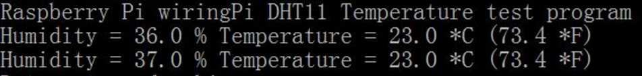

Figure : Results provided by the DHT11/ Raspberry Pi

#### B – Altitude, and Temperature, Pressure and Sea Level Pressure

The BMP180 allows more measurements than needed in the first place, but having extra measures for a weather system is an advantage, as long as it doesn’t slow the acquisition and transmission down.

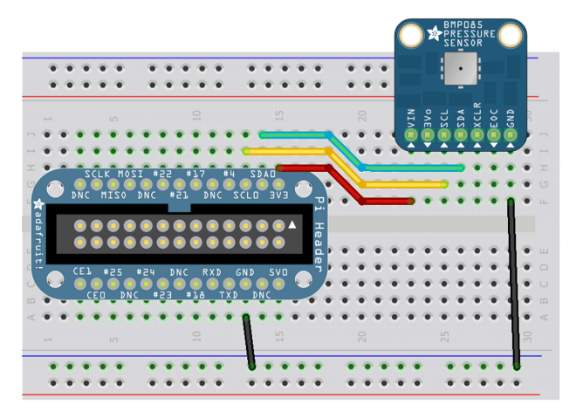

Figure : Wiring the BMP180

The wiring of the sensor can be seen on the left figure, and shows how to connect it to an extended GPIO board.

It would bring the same to wire it directly to the RPi.

This device uses the I2C (pronounced I squared C), which is a bus for controlling external devices with the RPi, such as sensors.

This bus will be used for the next sensors as well, but its explanation will only be made in this section.

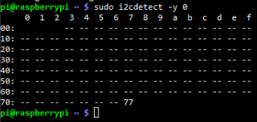Using the command “i2cdetect -y 1”, meaning detect what is used by I2C for a raspberry Pi 2 (it would be changed to a 0 for an older model), will show which port is used and what device is connected.

Then, the according libraries are installed (Adafruit python BMP library) and the code can be run to obtain the following output:

Figure : I2C detect

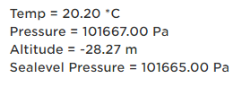The code being in python, it is very to implement it alongside the other sensors.

Figure : Results brought by the BMP 180

#### C – Luminosity

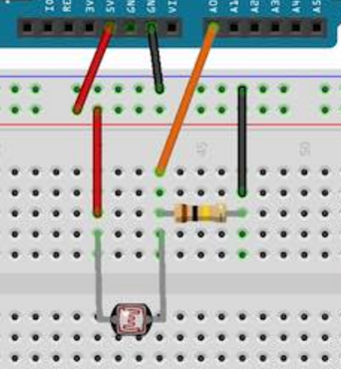The luminosity is monitored with a simple LDR sensor hooked on an Arduino Nano, slaved to the raspberry pi with the help of the SPI bus. Can be seen below the LDR connected to the Arduino Uno.

Figure : LDR and Arduino

The Arduino slaved to the RPi, is done through the I2C once again. It allows to communicate between the two devices. On the screen obtained for the BMP180

sensor, using i2cdetect, can be seen an address. This address is selected for Arduino, and then can be incorporated in the python code to read, or write to it.

It allows then to have analogue measurements, such as the one from the LDR, directly received on the RPi.

Also, it is to be noted that the value is already convert in percentage of light, on the

Arduino before sending it, so it eases the RPi from another calculation.

#### D – Time and Position

The position is taken by the GPS (Ublox NEO-6m), which also provides an RTC (Real Time Clock) and an altitude monitoring. Here is how it wired:

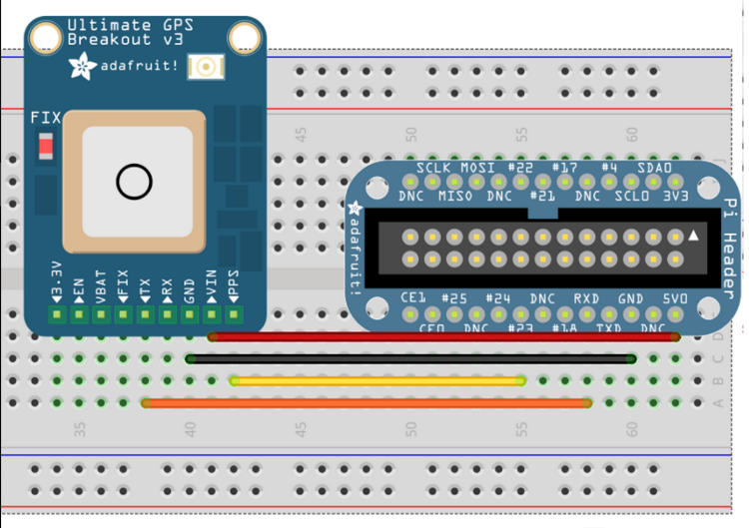

Figure : GPS wired to RPi

As for the previous sensors, the I2C is used, but within the SCL and SDA bus, which offers a different type of transmissions. The libraries are installed as following:

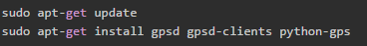

Then using gpsmon, can be obtained the following screen:

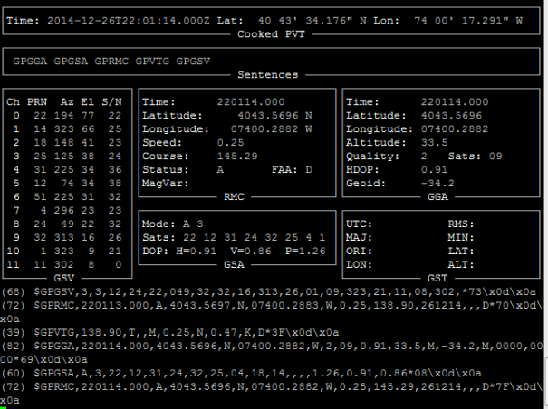

Figure : GPSmon screen and GPS data monitoring

Another method is used in the final python script, which get strings from the GPS with all data contained in a single line. The GPS as a latency of 1 second between two measurements.

### On-Board Memory

The Raspberry Pi is based on the SD memory card, that act as the hard drive of a computer. Its OS is installed on it, but it can also use this ROM to keep the data. It was decided none-the-less to keep sending data without saving it on the device itself, unless transmission issues were detected.

### Camera

A camera is installed on top of the device, called the PiCamera, and designed especially for the Raspberry Pi. It is accessible locally as it streams its content over Wi-Fi. Can be seen here how it was setup:

* Install apache server for Raspberry Pi, to allow stream of data.
* Keep the stream local, so there is no need for internet connection, which is a step ahead for expansion as if the Raspberry Pi were to be a hotspot as well, then the camera would have no need of connection other than the device from which it is accessed and the Raspberry Pi.
* The stream uses the mjpeg libraries, which instead of being a video feed is a high rate of image feed. The developed PHP website will be handed.

A test can be seen below:

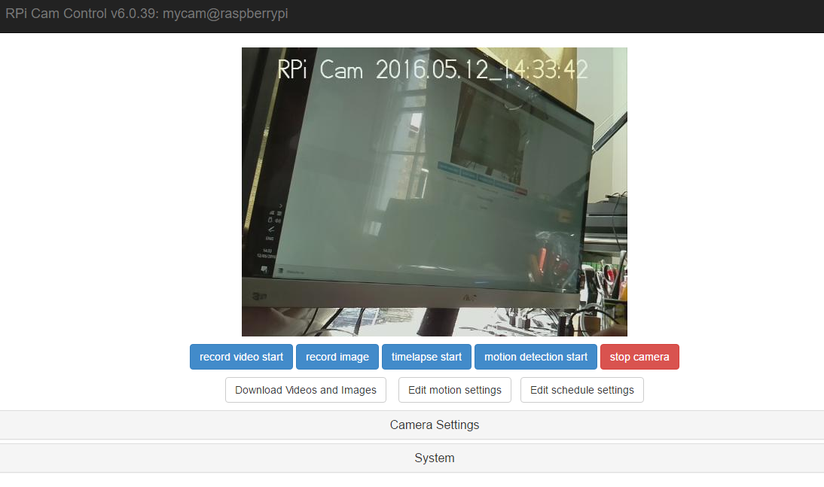

Figure : Camera test for Raspberry Pi

The framerate here is of about 25FPS, with a good enough resolution of 720p.

### Wheel System

The Wheel system is used to provided mobility to the system. It was not implemented, as requested by the optional requirements of the project definition only.

It is however accessible only if the user is at short distance from the device, as it uses Wi-Fi to communicate.

Will be seen on next page the wheel set chosen if the expansion were to be done. It was purchased and mounted, tested but not with Raspberry Pi. It uses L293D controllers to manage the wheels.

Here is the wheel system:

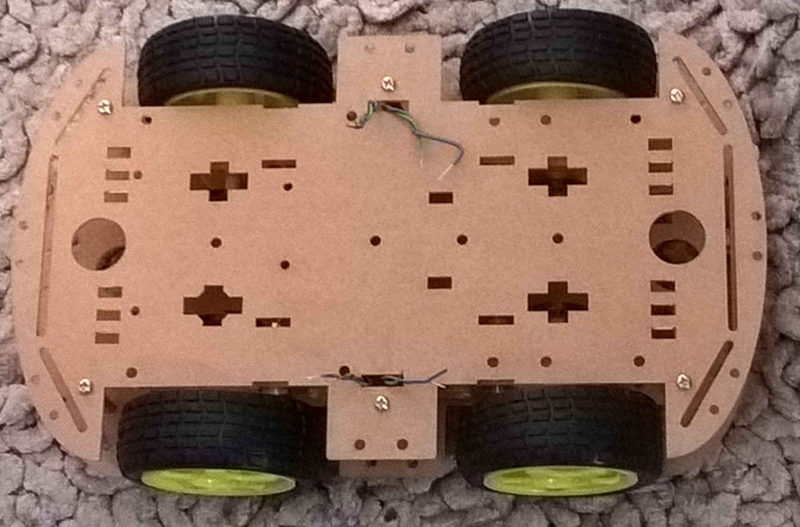

Figure : Wheel system

And how it is wires with the L293D and Raspberry Pi:

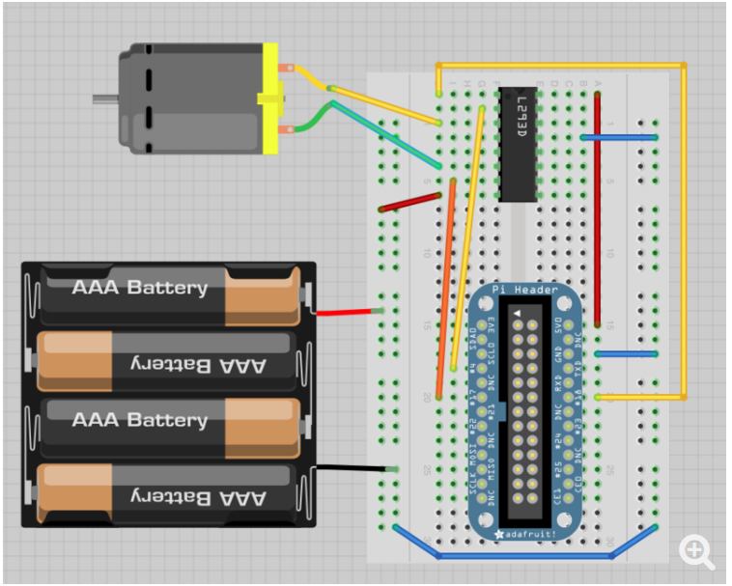

Figure : Circuit for Motor controls

The data for movements would have been taken from an input on the website shared by the raspberry pi as a JavaScript or PHP input and then taken into python for motor controls.

### Powering, Battery and Solar panel

The robot not having mobility enhanced yet, it was not necessary to implement a battery system at the time.

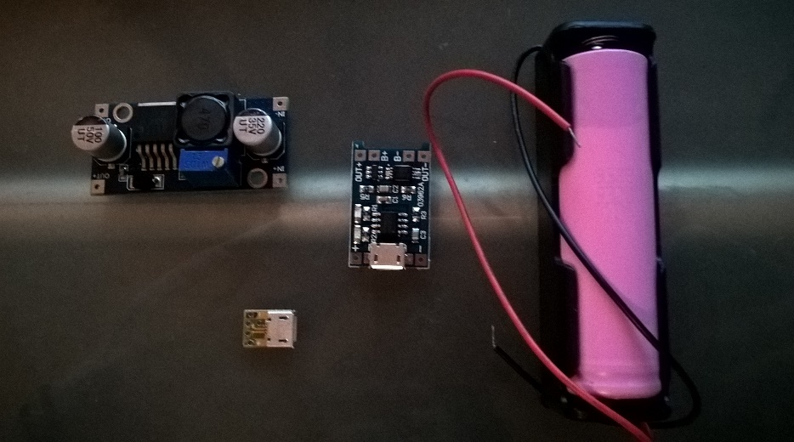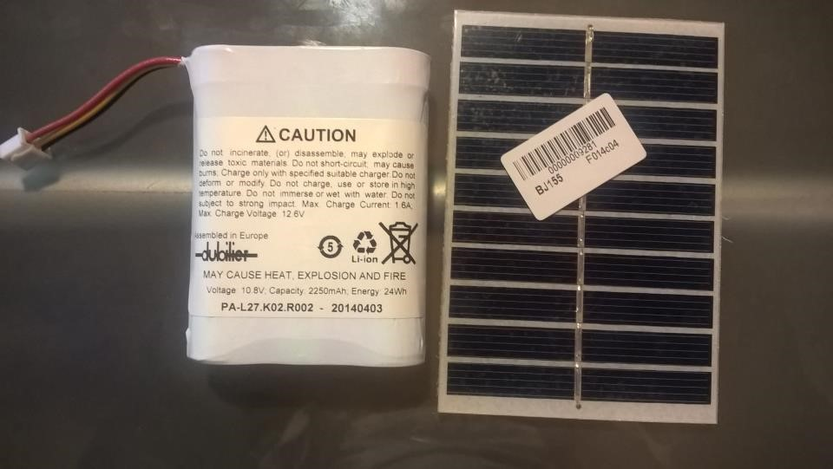However, all components were gathered to enable the expansion if enough time was lasting. Can be seen 5V solar panel, a 12V battery, a 12V to 5V transformer, and micro-USB adapters to make the charge universal.

Figure : Mobility power components

### WDT Prototype/Circuit

Here is the state of the circuit at the moment of writing the project:

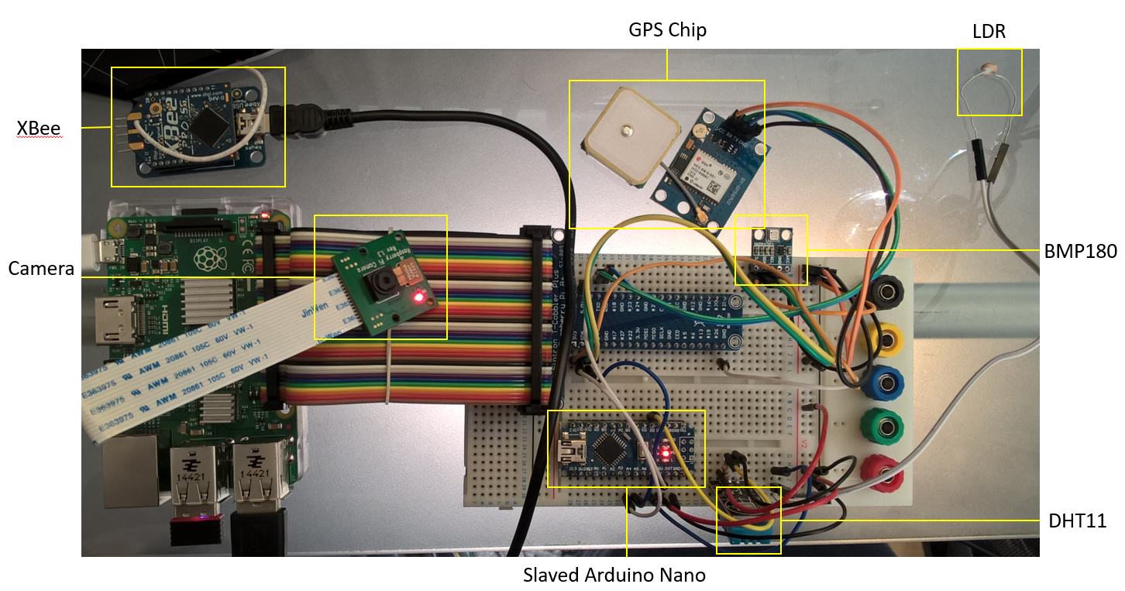

Figure : circuit of the WDT

# Aesthetics

A 3D printed case has been designed, so it would fit on the chassis of the wheels, and provide protection and better aspect to the system at the same time:

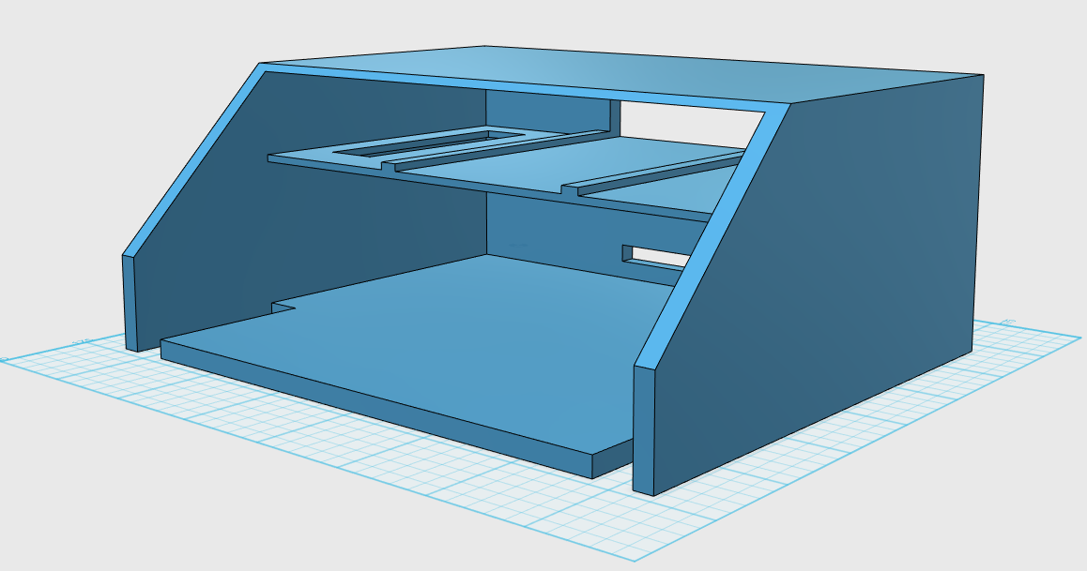

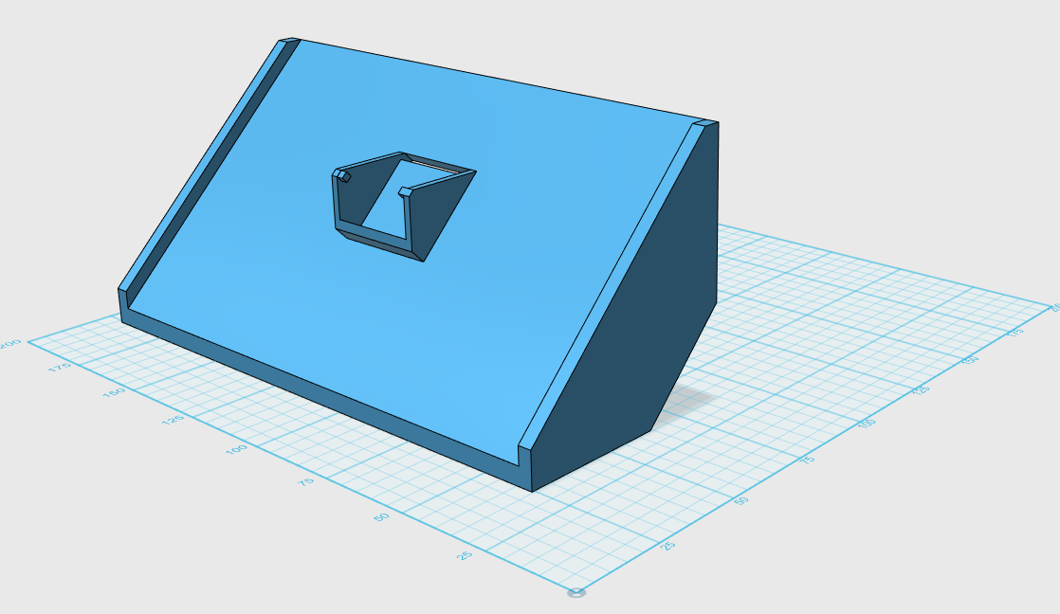

Figure : Case of the WDT

# Data Transmission

This section will show how the data is transmitted from the WDT to the Reception Unit, and then to the Database Server finally to be accessed by the website. It will be presented following the data flow.

## Data Transmission from Wireless Unit to Reception Unit

In order to ensure good communications between the WDT and the Reception Unit, was decided to use long distance communicating system. The choice went to Xbee modules. These devices are using an RF technology, at a Frequency of 868MHz on the ISM band, and allow very long distance (~40km) transfer considering their easy-configuration and cheap pricing. They are reliable, and easy to maintain as once it is configured, almost no software or settings update is required. They also provide protection of transmitted data and two-way communications, making them transceivers.

#### Wireless Transmitting Device (RF)

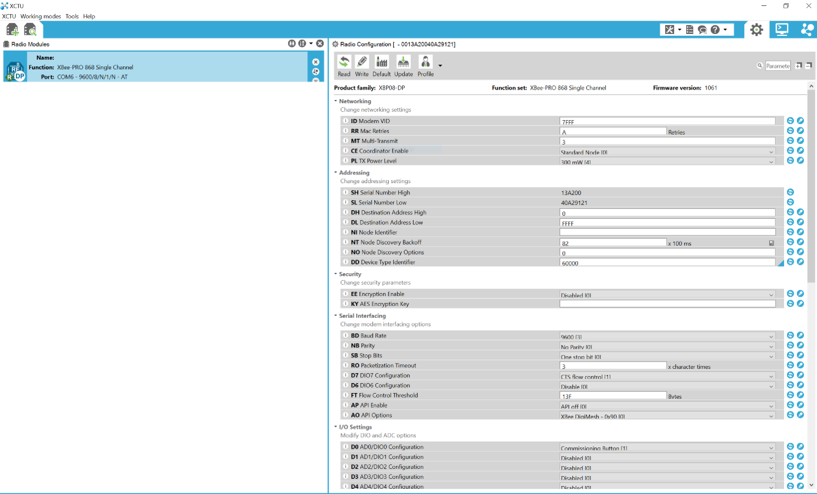Can be seen below the XCTU software (provided by DiGi) window, where the settings can be changed:

Figure : XCTU Xbee Configuration page

From this environment, when the two Xbee are connected it is possible to have them communicating with each other. Here is a small experiment done through the XCTU Console: When text is written from an Xbee to another, it is seen in blue from its view, and red by the other one.

Here is “Xbee One” view:

Figure : Xbee One Console view

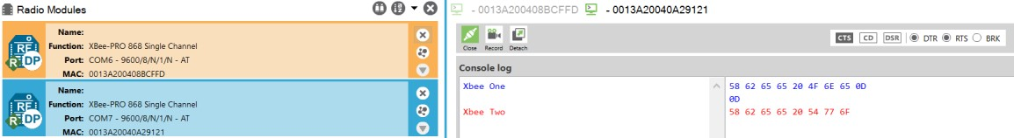

And “Xbee Two” view:

Figure : Xbee One Console view

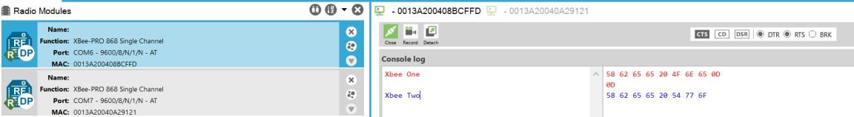

The two Xbee are communicating and are both Transceivers. They have been set to be on the same defined channel to transmit from one to the other, and also to reduce the chances of being disrupted or receiving noise/interferences

### Xbee on Raspberry Pi

The Raspberry Pi uses an Xbee to send the data acquired to the host computer. It can be connected in different way, the easiest being using an USB connection between the Pi and the Xbee.

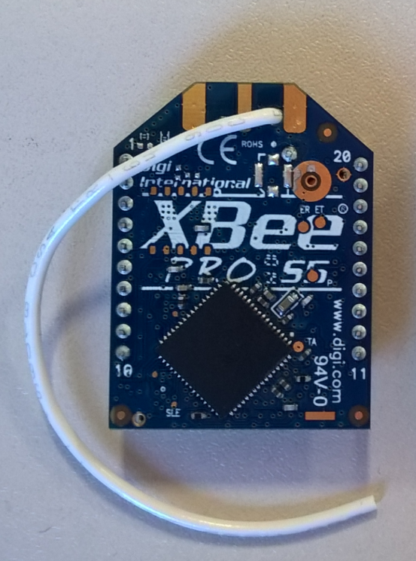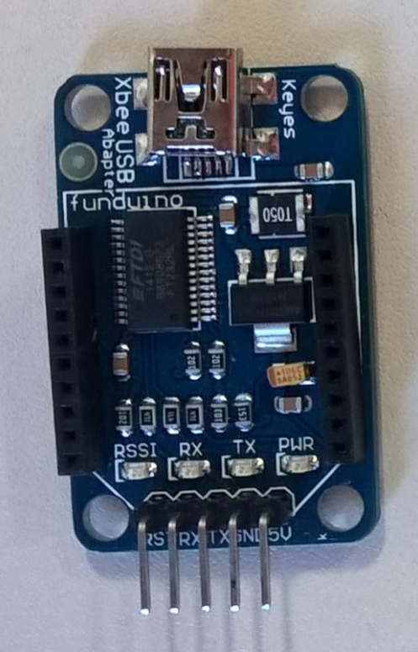In the final version of this circuit, to keep the highest data rate possible at the transmission end, the Xbee is connected via USB, and python libraries are installed so it is accessed through serial port.

Figure : Xbee and its USB connector

The code to use the Xbee in USB – Serial connection can be found in the main program, as it is very straight-forward to be used. The testing was done as follow:

* The command lsusb was used to detect the freshly connected device.
* Then, Python Serial library was installed, in order to connect to the USB via serial and send/receive data from the Xbee.
* 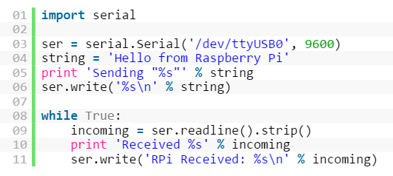Run the following program, specifying how the connections is to be set (Baud rate of 9600, parity bit of 0 by default, and one stop bit):

Figure : Python program for Xbee

This program sends a test line, and then wait for answer, that is sent through the C# program designed for the occasion, and that is shown in section “Data Transmission”.

### Data to be transmitted

After trying to send and receive sample and tests of data through XCTU, and after having configured the Xbee to work with the Raspberry Pi, it was time to try sending live and real data to test its capabilities.

At first, the data transmission occurred without major issues, and was made by simply sending strings with the values included. But when testing the reception end, was noticed a very long timing between the reading of two successive lines, and that when they would be received they would come eight by eight.

It was thought at first that a timing or delay issue was the cause, but what was understood afterward was that in fact the line weren’t incorporating “breaks”. The break means the end of the line, and is represented by return on keyboards.

The solution was then to simulate the line break, using the according equivalent in ASCII, which is “/r”, or sometimes “/r/n” to end line in more systems.

Once the data was appearing line after line, it was then found the need to specify what was the values, where they would start or stop in the string, what was the associated parameter…

Therefore, it was decided to separate the data from the sensors and from the GPS parameters, as they don’t have the time needed to acquire data from on or the other is different.

It is to be reminded that the sensor array can provide up to 8 stable measurements a second, while the GPS needs about a second.

Then each type of measurement would be put in a single string, one for the sensors measurements, starting by the word “strVal” to help notice the start of values transmission, and one for the GPS measurements which would start with “strGPS”.

To help understand the measures used to answer this matter, here is a small piece of the main python program used to transmit the data:

serXbee.write(val)

serXbee.write('\r\n')

It shows that it first sends the transmission, and terminates it with the return.

### Host PC

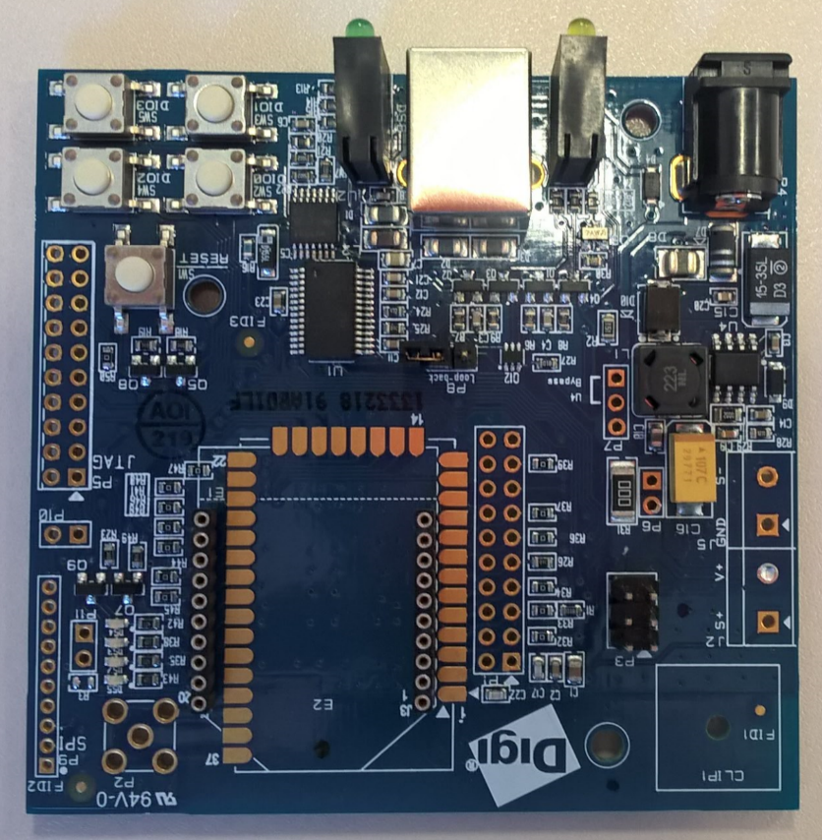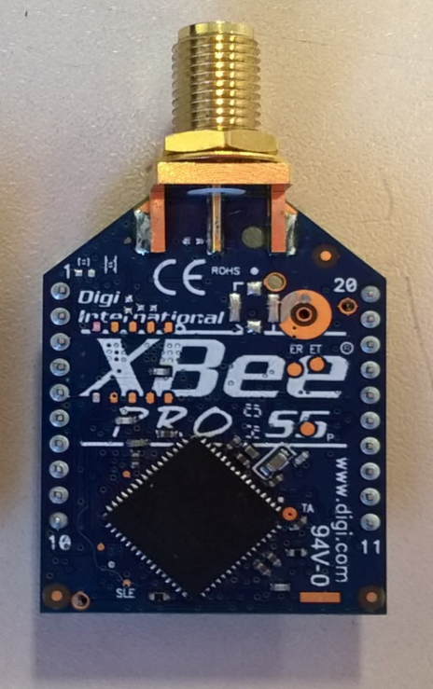The Xbee for the PC Host is connected to USB using the following platform:

Figure : Xbee Adapter for Host PC

It is then possible to access the Xbee via a simple USB connection. Serial was used to access the data transmitted. How the upload is handled is shown in the next section.

### Data Upload

A C# program I used to upload the data to the online database. It reads from the USB port the values transmitted by the Xbee, and then works out the data to make it easy to manipulate once online.

The program simply listens to the port, and then depending on if it received “StrVal” or “StrGPS”, it will then upload it to the according database, as they use separate storage spaces.

In order to retrieve the data from the transmitted line, it parses the data knowing where each value should be (Temperature first, then altitude …).

If the line comports some values, it does not upload the data, as it means either the data transmission is not working well, corrupted, or that the sensors values are out of range.

It uses the C# MySQL connector to upload the data online, and the text/string library for C# in order to split the received strings. It doesn’t convert the type of the values as they are converted by PHP on the very end.

## Database server

The data transmitted is stored on a MySQL database server. It is a virtual server service provided by digital ocean (<https://cloud.digitalocean.com>), and is an asset of the GitHub student pack. It allows to create “droplets”, which are virtual servers of small or large size, mainly accessible through VNC, and offering a command window on the website itself. The access the PHPMyAdmin console which is installed on this server will be explained in the next section.

Management of the droplets works as below:

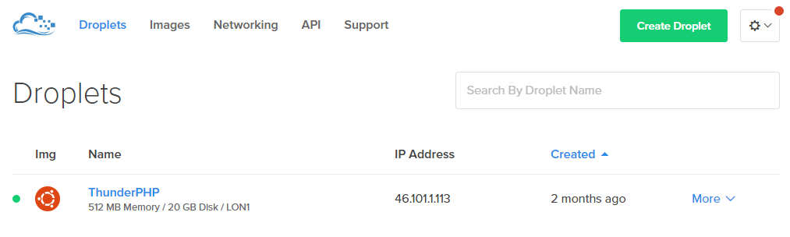

Figure : Droplets window

The “more” button offers to access the database, and provides other links to the main management options.

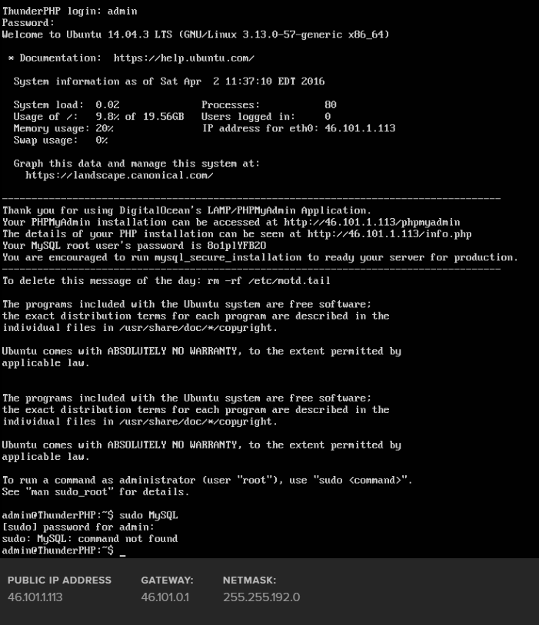Can be seen here the VNC access directly in the browser:

Figure : VNC access to the database server

### Proof of concept – Access the database server

The database can be accessed through the phpMyAdmin console: <http://46.101.1.113/phpmyadmin>.

It of course requires authentication, and the following credentials can be used for checking:

Username: RemoteBot_Admin Password: ReMote_BOT_1302

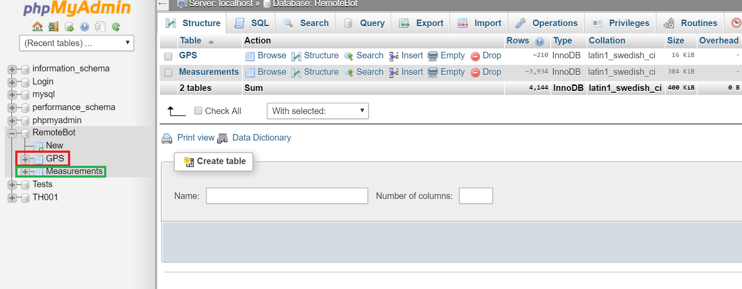The data can be accessed through the following console. It is located under RemoteBot, and then the GPS or measure tables, depending on what values is to be browsed through:

Figure : phpMyAdmin Console for management

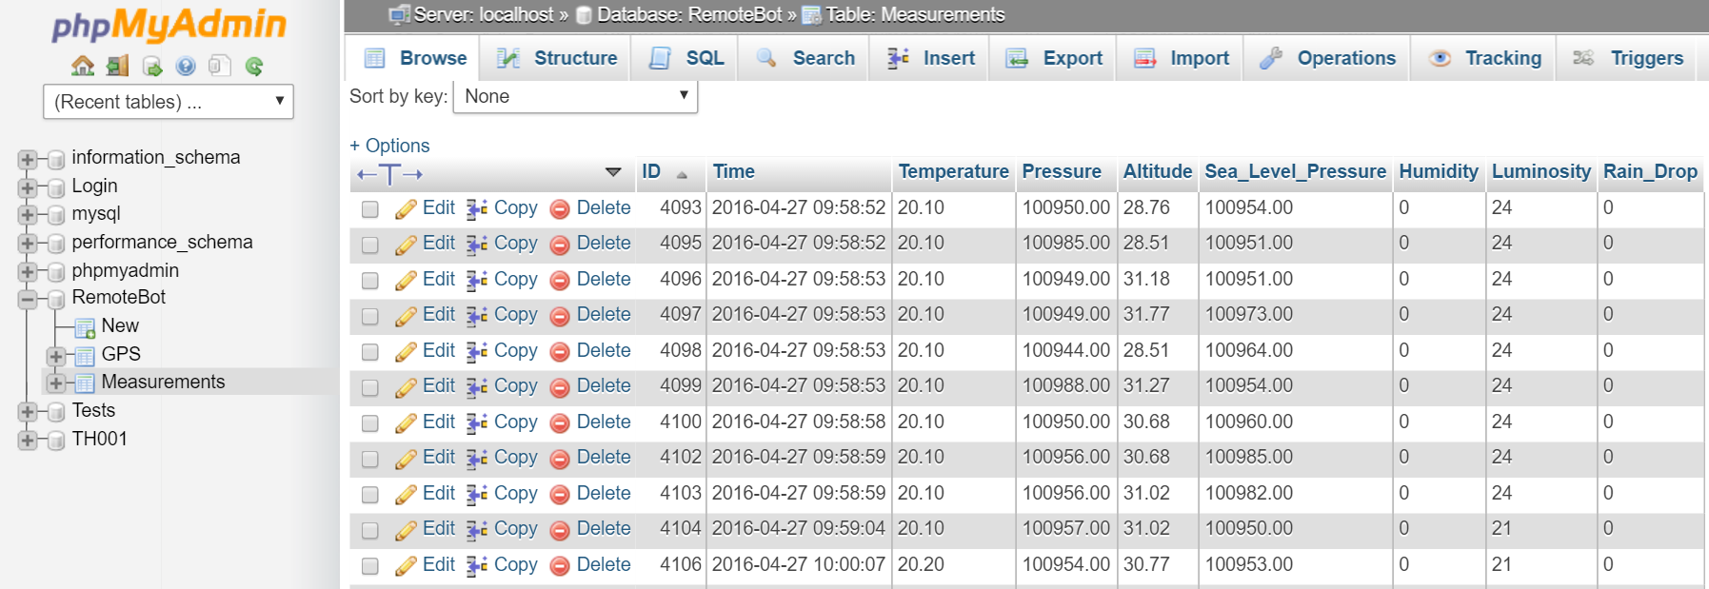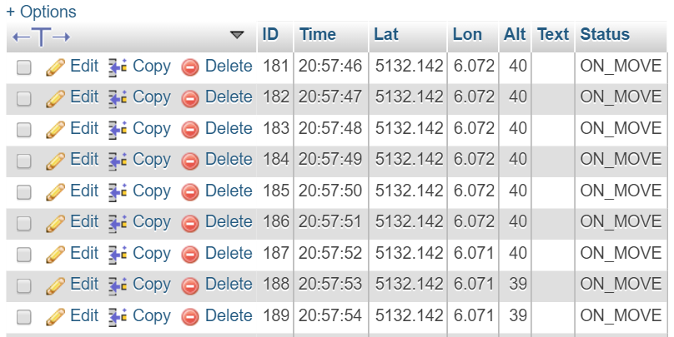It is then possible to go through the measures, and sort or rearrange them for better visibility:

Figure : phpMyAdmin – Browse through measurements

Figure : phpMyAdmin – Browse through GPS data

# Data Access and Manipulation

The data being stored online on a database server, its access it straight-forward. All that is needed is the address of the database server, and then the credentials needed to allow communications with the database itself.

On the website and the dashboard, PHP is used as the main communicator. The data is then brought into JavaScript scripts using AJAX and JSON, in order to manipulate it and include it into charts on the website.

## Website

The website is hosted on a windows virtual server 2012R2, service provided by Amazon Web Services (<https://aws.amazon.com/>) and part of the GitHub Student Pack as well.

The Website is accessible at <http://www.remotebot.tech>.

A website GUI was developed with the main aim of offering access to the data, on any platform, at anytime and anywhere. It allows the user to have instant access as well, and can be easily password protected if data is said to be sensitive.

The website itself represents more of an explanation or presentation of how the product works. The real data is mainly shown through the dashboard.

The website was developed with HTML and CSS for the architecture and design, offering a very simplistic and basic theme. The dark colours in the background helps to magnify the text and pictures impact, and the reading in general.

The animation and adjustments are provided through JavaScript, that for example adjust the size of the element depending on the user screen size. It also makes the navigation easier, working as a full-screen website, and letting the user use keyboard arrows to navigate, or even through the fact that it is not possible to scroll between two pages.

The website will shortly support an SSL certificate, and google analytics to help understand the impact and vision of the website over the internet, while protecting it against major threats.

### Amazon Web Services

The use of Amazon cloud, was a difficult to understand at first. Here is an example of few of the services that are available for use on the Amazon cloud dashboard:

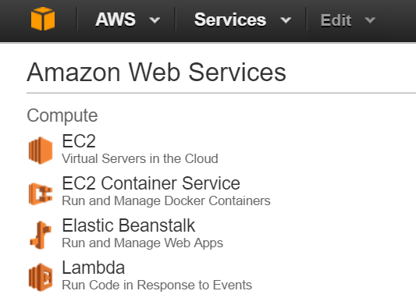The EC2 option on the left is the one in use. It is called elastic computing cloud, and allow to grow the data capabilities and power of the virtual server depending on its use.

Of course, with the objective of avoiding bad financial surprises, it is possible to limit it and to block this asset, in order to stay within the range provided of free services.

Then within the EC2 service, was possible to create an instance, as shown after.

Figure : Amazon Cloud Services

Here can be seen step by step how was created the instance (Following the Instructions given by Amazon Cloud). Here are the steps to be followed:



Figure : Steps to create an instance on AWS

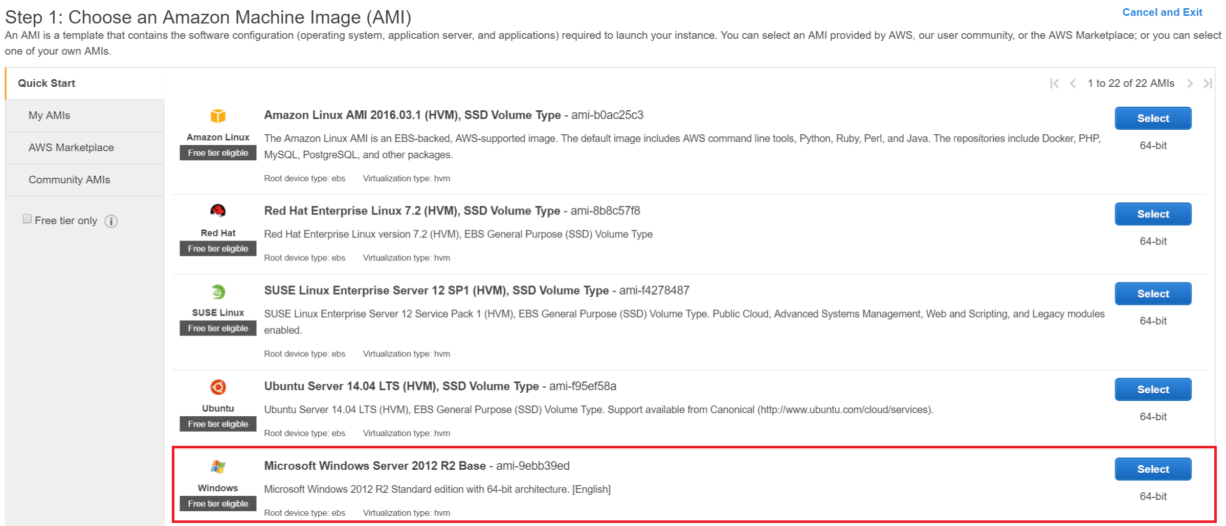Then, Step 1, choice of the type of instance (Operating systems):

Figure : AWS Instance Creation Step 1

Can be seen that the selected instance is Microsoft Windows Server 2012 R2 Base. It is written as available in the free tier, and once setup it can be used as a web server. These capabilities and the personal knowledge of windows server made this decision easier. Of course more are available as well.

The following panel shows the choice of instance model:

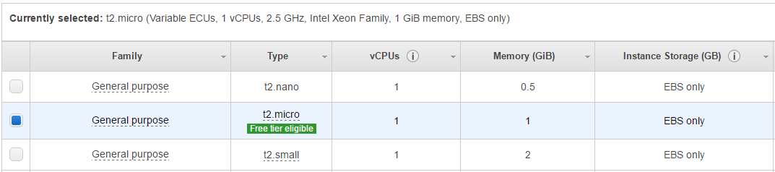

Figure : AWS Choice of model of instance

Then can be revised the details of the instance:

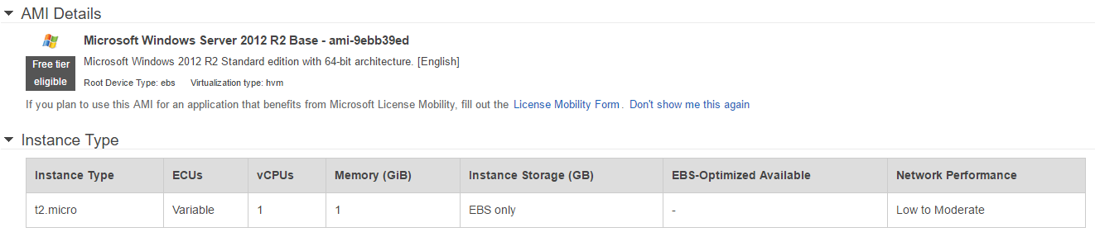

Figure : AWS Review of Instance launch

Many more options are available, as name of the instance, storage and performances parameters, network setup… The instance in use uses the default options.

Here can be managed the security and state of the instances, and to access to the instances themselves:

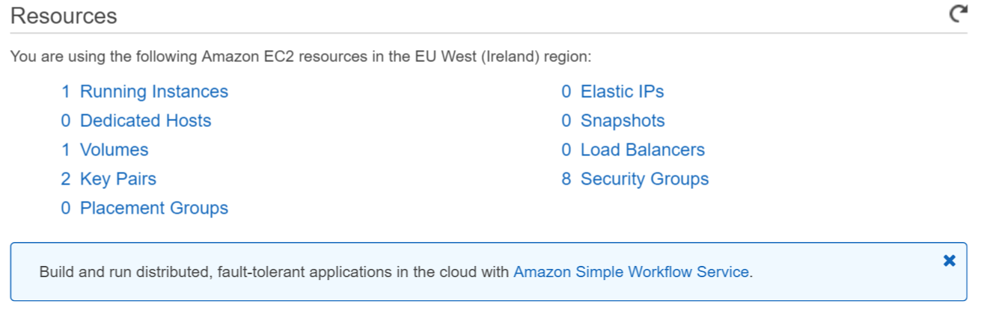

Figure : AWS Resources page

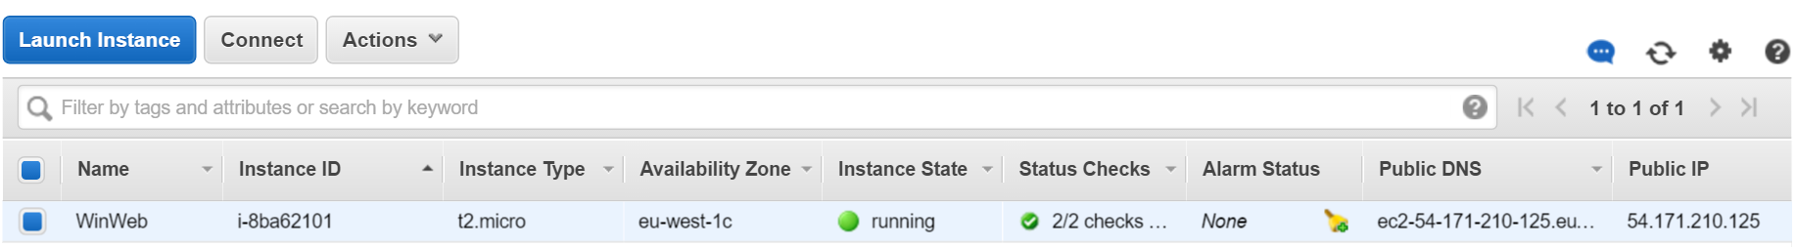The instances console is shown below:

Figure : AWS Running Instances

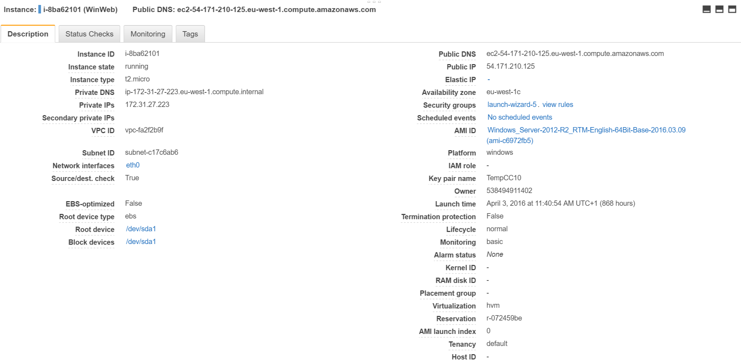And the details associated:

Figure : AWS Instance Details

Here can be seen the details of the instance, for easy remote connection or simply information about its status and details.

### Webserver side

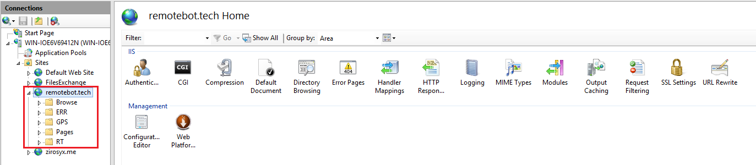The webserver is needed as only this kind of machines can run PHP scripts. It is seen below the IIS (Internet and Information services) windows, with on its left the navigation tree, and on its right all the options provided and that were modified in order to give the best experience possible:

Figure : IIS Dashboard

### Dashboard

The dashboard is hosted alongside the Website. It is accessible at:

<http://dashboard.remotebot.tech>.

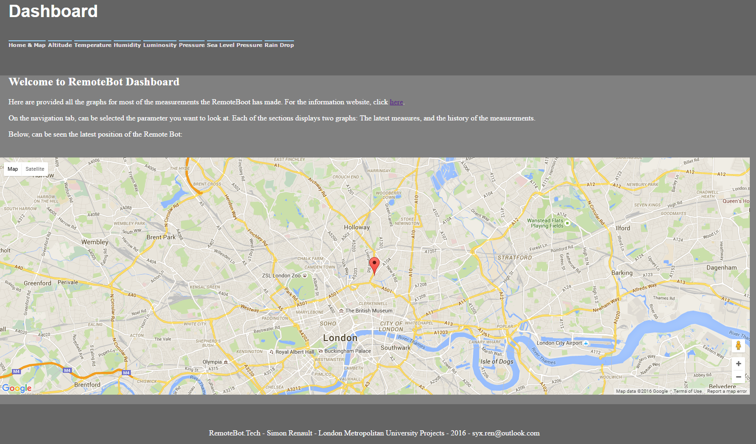The dashboard is just another page of the website, with a more result-oriented approach. It provides a more efficient way to access the data, and history results that are only accessible on this page:

Figure : Dashboard

Can be seen on its banner on the top that all the parameters measured are accessible here. They provide ease of access, and each parameters having its own section was the easier way to show full page and easy to visualize graphs.

The home page shows the map, with the real-time position of the robot. It was created using the google maps API, and is using the MySQL database to store the position of the robot. An history of the position can also be found on the database itself.

Below, can be seen an example of one of the sections, Altitude. It shows on top the Real-Time graph, which is updated every second, and is followed by an history of the data over time.

At the moment at which the picture is taken, the robot is off, and the real-time value stays at the same level as nothing is uploaded.

Here is the Altitude section of the Dashboard:

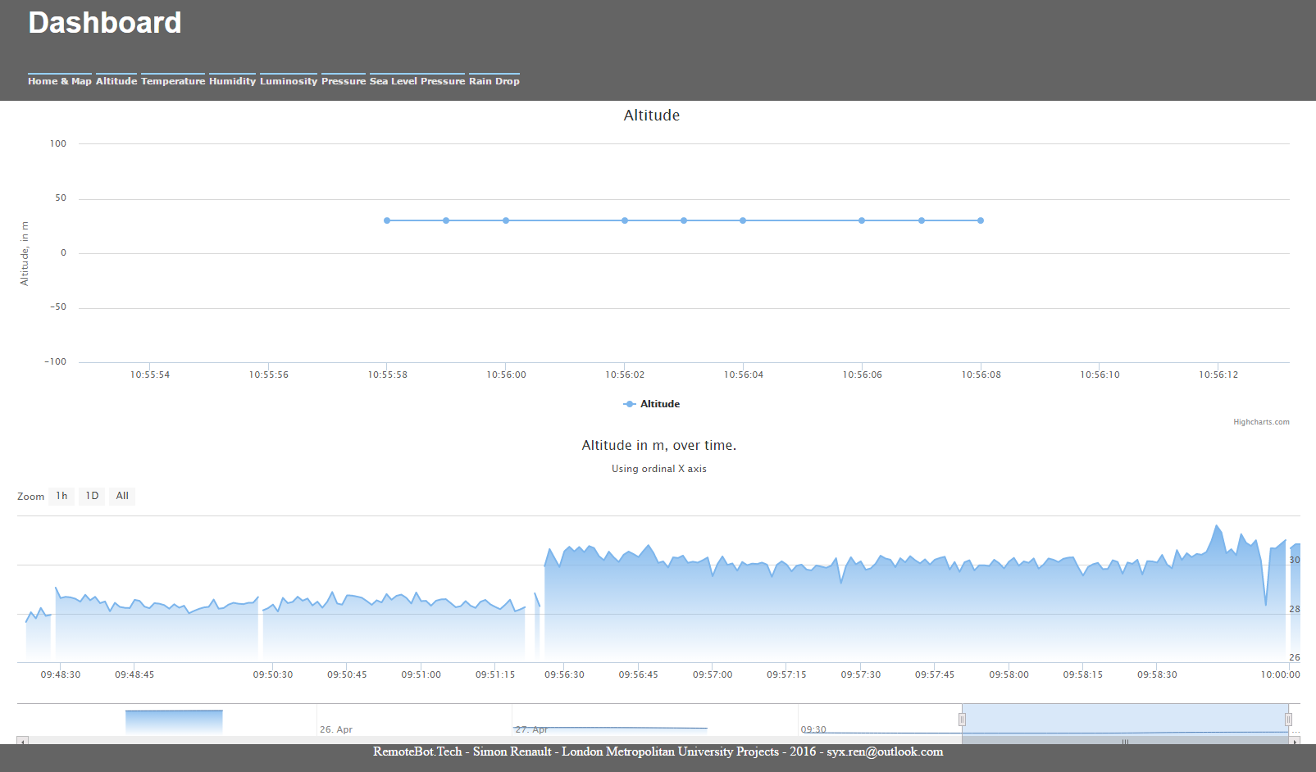

Figure : Dashboard, Altitude section

The data history graph presents the data overtime, and can be seen the option to scroll through it at the bottom. It also allows to zoom in and so to see the values of each sample one after the other.

Video of the working system:

<https://www.youtube.com/watch?v=tcmoFmnHfZQ&feature=youtu.be>

## Other types of Data

The camera can be accessed at the Raspberry Pi IP address. It then shows the following menu:



Figure : Camera view from Raspberry PI

Can be seen below the camera capture, a set of options. They allow modification and optimization of the camera output. Also, it is possible to integrate a link into an Android app, just allowing to access this page.

The app is not developed at the moment.

Motion detection is enabled.

Video of the working camera:

<https://youtu.be/E-yXsRKePYk>

# Working example

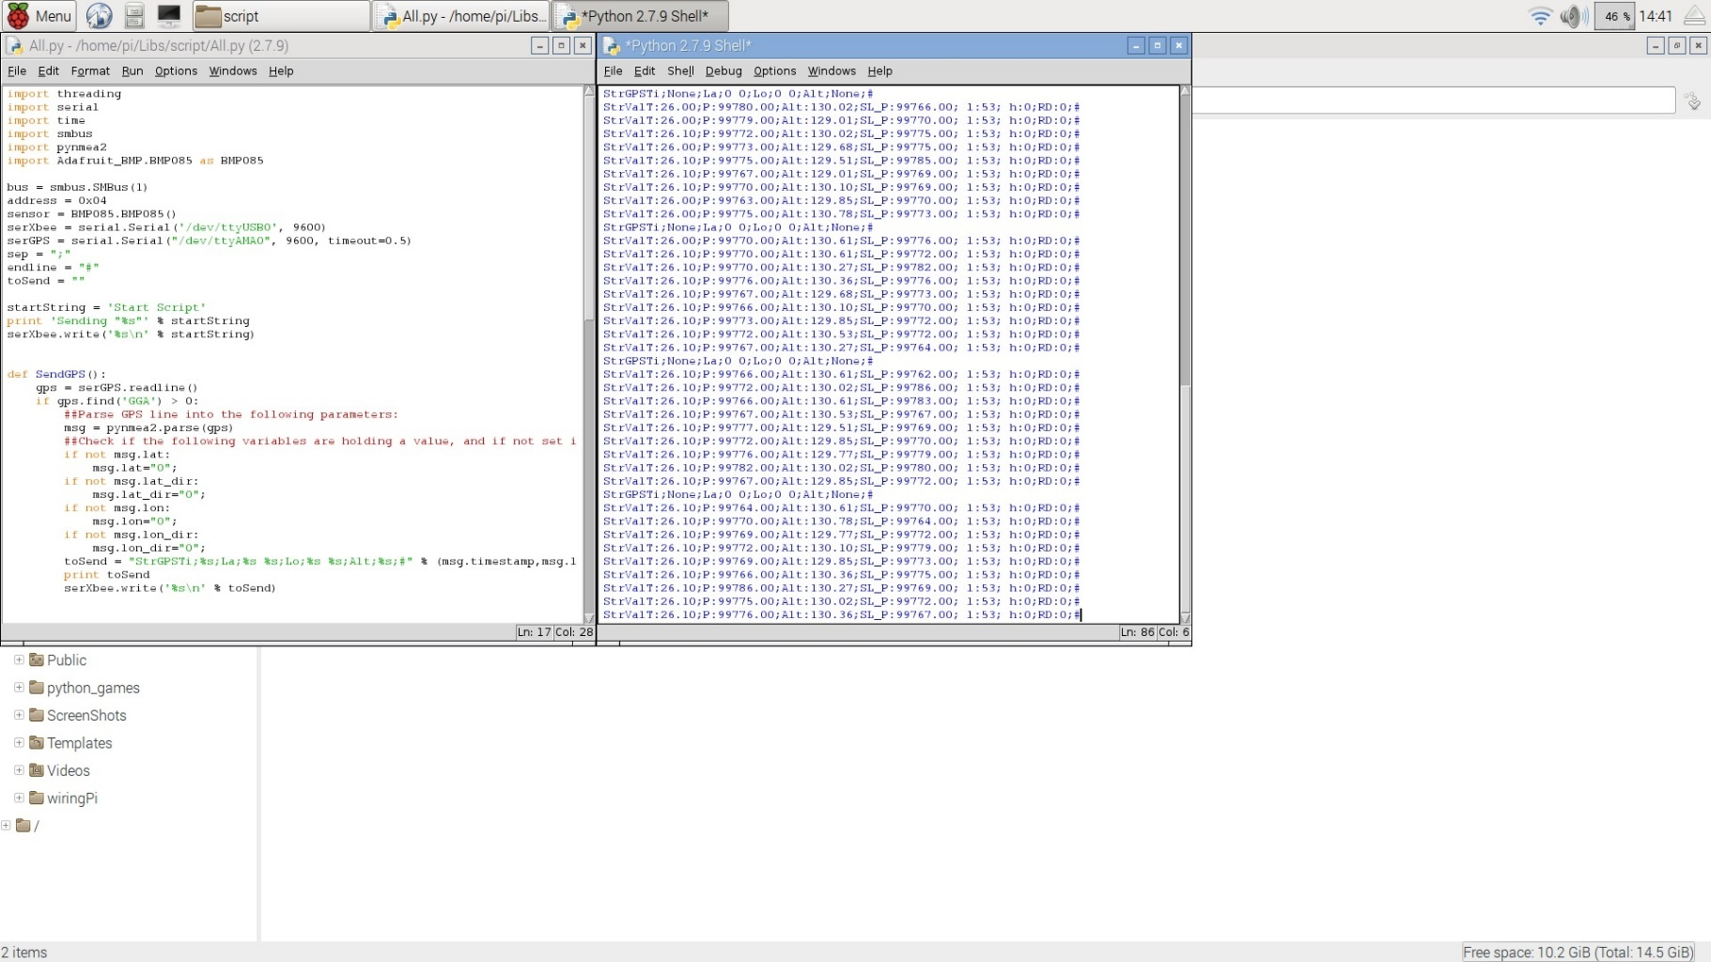Can be seen a working example, on the different devices in use. The Raspberry Pi:

Figure : Working example – Raspberry Pi

On the host PC:

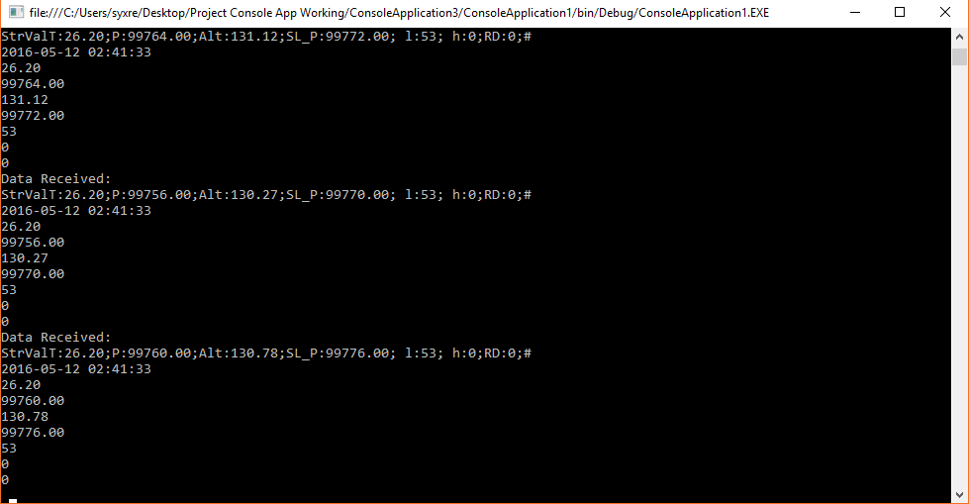

Figure : Working example – host PC

And in video on the dashboard [here](https://www.youtube.com/watch?v=tcmoFmnHfZQ&feature=youtu.be) (Luminosity example).

# Conclusion

## Time management

## Economic and Ethical aspects

## Progress Review

The progress on the project has been following the timetable quite well: Most of the sensors were ready for use on time, the wireless modules are ready and will be configure following the needs of both sides (WDT and Host Computer). The chosen processor is reliable and running well, the battery and solar charging units are ready for implementation, which is done a week in advance.

Despite the respect of the time-line agreed at the beginning of the project, unattended issues happened. More time is needed to configure all the sensors, and bring them on the same platform, due to misevaluation of the difficulty of interfacing the DHT11temperature sensor, late deliveries and faulty components. Time will also need to be dedicated for the programming of the microcontroller, and its testing.

# References

1. Silicon Labs (2015) *EFM32 Zero Gecko Datasheet,* Available at:

[*https://www.silabs.com/Support%20Documents/TechnicalDocs/EFM32ZG222.pdf*](https://www.silabs.com/Support%20Documents/TechnicalDocs/EFM32ZG222.pdf)

(Accessed: 31st September 2015).

1. Jacob Fraden (2010) Handbook of Modern Sensors. Springer [Online]. Available at: *http://folk.ntnu.no/andberge/Sensors.pdf* (Accessed: 10th October 2015).
2. D-Robotik UK (Translation of MICROPIK) (2010) DS1307 Datasheet,Available at: *http://www.micropik.com/PDF/dht11.pdf* (Accessed: 31st September 2015).
3. VEX Robotics (2005) VEX Light Sensor Datasheet,Available at:

[*http://content.vexrobotics.com/docs/inventors-guide/light-sensor-final.pdf*](http://content.vexrobotics.com/docs/inventors-guide/light-sensor-final.pdf)

(Accessed: 31st September 2015).

1. BOSH Sensortec (2013) BMP185 Datasheet,Available at: [*https://www.adafruit.com/datasheets/BST-BMP180-DS000-09.pdf*](https://www.adafruit.com/datasheets/BST-BMP180-DS000-09.pdf)

(Accessed: 31st September 2015).

1. Maxim Integrated Products (2015) DS1307 Datasheet,Available at:

[*http://datasheets.maximintegrated.com/en/ds/DS1307.pdf*](http://datasheets.maximintegrated.com/en/ds/DS1307.pdf)

(Accessed: 31st September 2015).

1. jmbranco76 (2015) Solar power and Battery Connections,Available at: *http://www.element14.com/community/community/design-challenges/verticalfarming/blog/2015/10/01/modular-farm-blog-post-9--solar-energy-part-i* (Accessed: 1st December 2015).
2. Digi International (2015) *Xbee PRO 868 Specifications,* Available at: *http://www.digi.com/pdf/ds_xbeepro868.pdf* (Accessed: 30th November 2015).
3. Farnell (2015) *A000096 Datasheet,* Available at:

*http://www.farnell.com/datasheets/1751331.pdf* (Accessed: 31st September 2015).

1. Joseph Albahari & Ben Albahari (2012) *C# 5.0 in a Nutshell*, 5th edn., United States of

America: O'REILLY.